BYTEWISE FELLOWSHIP PROGRAM

DATA ENGINEERING

Tehreem Fatima

**WEEK 2**

**20– March -2023**

***Task No 05***

***Write a few lines about Data Types In SQL with examples:***

In SQL, data types define the type of value that can be stored in a table column. The most common data types include:

* INT - Integer: used to store whole numbers, such as 1, 2, 3, etc.
* VARCHAR - Variable-Length Character: used to store variable-length strings, such as "hello world".
* DATE: used to store date values, such as "2022-08-03".
* DECIMAL - Decimal Number: used to store decimal numbers, such as 3.1415.

Here are some examples of SQL statements that use data types:

* CREATE TABLE example_table ( id INT, name VARCHAR(50), date_created DATE, salary DECIMAL(10,2) );
* INSERT INTO example_table (id, name, date_created, salary) VALUES (1, 'Jane', '2022-07-15', 50000.00);
* SELECT name, salary FROM example_table WHERE date_created BETWEEN '2022-06-01' AND '2022-08-01';

These statements create a new table called "example_table" with columns for ID, name, date created, and salary. They insert a new row of data into the table, and then select and display data from the table based on a specific date range.

***MySQL Data Types***

A list of data types used in MySQL database. This is based on MySQL 8.0.

***MySQL String Data Types10s***

|  |  |
| --- | --- |
| CHAR(Size) | It is used to specify a fixed length string that can contain numbers, letters, and special characters. Its size can be 0 to 255 characters. Default is 1. |
| **VARCHAR(Size)** | It is used to specify a variable length string that can contain numbers, letters, and special characters. Its size can be from 0 to 65535 characters. |
| **BINARY(Size)** | It is equal to CHAR() but stores binary byte strings. Its size parameter specifies the column length in the bytes. Default is 1. |
| **VARBINARY(Size)** | It is equal to VARCHAR() but stores binary byte strings. Its size parameter specifies the maximum column length in bytes. |
| **TEXT(Size)** | It holds a string that can contain a maximum length of 255 characters. |
| **TINYTEXT** | It holds a string with a maximum length of 255 characters. |
| **MEDIUMTEXT** | It holds a string with a maximum length of 16,777,215. |
| **LONGTEXT** | It holds a string with a maximum length of 4,294,967,295 characters. |
| **ENUM(val1, val2, val3,...)** | It is used when a string object having only one value, chosen from a list of possible values. It contains 65535 values in an ENUM list. If you insert a value that is not in the list, a blank value will be inserted. |
| **SET( val1,val2,val3,....)** | It is used to specify a string that can have 0 or more values, chosen from a list of possible values. You can list up to 64 values at one time in a SET list. |
| **BLOB(size)** | It is used for BLOBs (Binary Large Objects). It can hold up to 65,535 bytes. |

***MySQL Numeric Data Types***

|  |  |
| --- | --- |
| BIT(Size) | It is used for a bit-value type. The number of bits per value is specified in size. Its size can be 1 to 64. The default value is 1. |
| **INT(size)** | It is used for the integer value. Its signed range varies from -2147483648 to 2147483647 and unsigned range varies from 0 to 4294967295. The size parameter specifies the max display width that is 255. |
| **INTEGER(size)** | It is equal to INT(size). |
| **FLOAT(size, d)** | It is used to specify a floating point number. Its size parameter specifies the total number of digits. The number of digits after the decimal point is specified by **d** parameter. |
| **FLOAT(p)** | It is used to specify a floating point number. MySQL used p parameter to determine whether to use FLOAT or DOUBLE. If p is between 0 to24, the data type becomes FLOAT (). If p is from 25 to 53, the data type becomes DOUBLE(). |
| **DOUBLE(size, d)** | It is a normal size floating point number. Its size parameter specifies the total number of digits. The number of digits after the decimal is specified by d parameter. |
| **DECIMAL(size, d)** | It is used to specify a fixed point number. Its size parameter specifies the total number of digits. The number of digits after the decimal parameter is specified by **d** parameter. The maximum value for the size is 65, and the default value is 10. The maximum value for **d** is 30, and the default value is 0. |
| **DEC(size, d)** | It is equal to DECIMAL(size, d). |
| **BOOL** | It is used to specify Boolean values true and false. Zero is considered as false, and nonzero values are considered as true. |

**MySQL Date and Time Data Types**

|  |  |
| --- | --- |
| DATE | It is used to specify date format YYYY-MM-DD. Its supported range is from '1000-01-01' to '9999-12-31'. |
| **DATETIME(fsp)** | It is used to specify date and time combination. Its format is YYYY-MM-DD hh:mm:ss. Its supported range is from '1000-01-01 00:00:00' to 9999-12-31 23:59:59'. |
| **TIMESTAMP(fsp)** | It is used to specify the timestamp. Its value is stored as the number of seconds since the Unix epoch('1970-01-01 00:00:00' UTC). Its format is YYYY-MM-DD hh:mm:ss. Its supported range is from '1970-01-01 00:00:01' UTC to '2038-01-09 03:14:07' UTC. |
| **TIME(fsp)** | It is used to specify the time format. Its format is hh:mm:ss. Its supported range is from '-838:59:59' to '838:59:59' |
| **YEAR** | It is used to specify a year in four-digit format. Values allowed in four digit format from 1901 to 2155, and 0000. |

***Task No 06***

***Practice about following in SSMS:***

***1 - SQL Constrains:***

***• Not Null, Unique, Default and Check constraints***

***• Primary Key and Referential Integrity or foreign key constraints***

**2 - Tables**

**• *Creating Table***

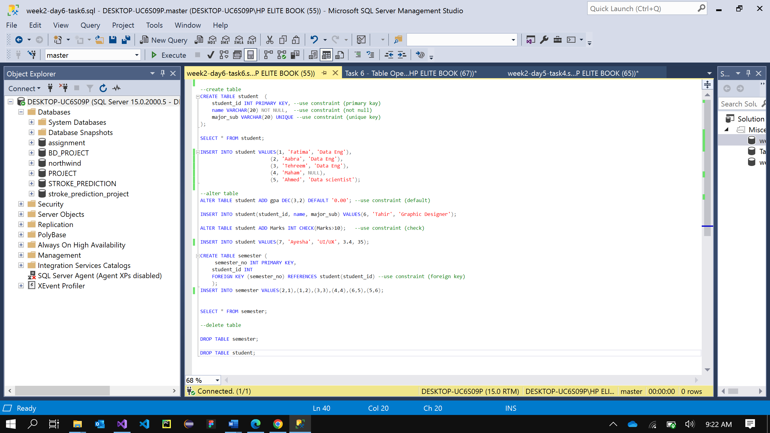

**• *Altering Table***

**• *Deleting Table***

